Dear College Community
Thank you everyone for your support as we prioritise the health, safety, and wellbeing of our students at this time to ensure the continuity of learning.

What does this mean for students?
Friday 13 August to Thursday 19 August inclusive will be pupil-free. Students should not attend school during the pupil-free period; however, they will need to continue their learning via Google Classrooms.
Teachers will be transitioning to online teaching to support academic and wellbeing needs. Teachers will provide students with the work to complete during the snap lockdown.
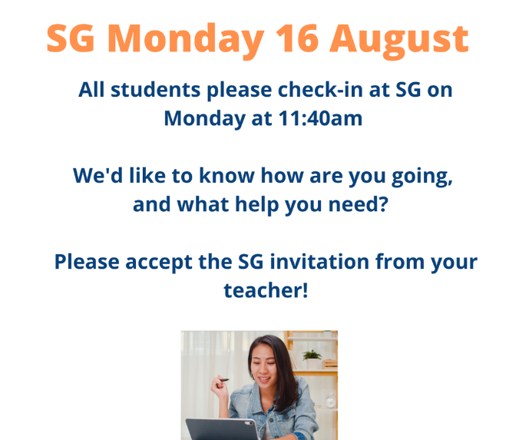

Check- in
Student Group (SG) teachers will be doing a check in with your child on Monday 16 August at 11:40am. Students join the meeting via their SG Classroom page.
Below is the post we have put on Google Classroom pages and on our social media for students.

Learning and Assessment
- Students should be using Google Classrooms effectively to ensure continuity of learning.
- Students can continue with course work and assignments.
- Assessment due for submission between now and next Thursday 19 August next week will be expected by Friday 20 August.
- In class assessments such as in class exams, in class essays and tasks are suspended and students will be notified about new assessment arrangements in the coming week.
- Communication for learning is via Google Classroom.
If students have concerns about content relating to individual classes, please contact the teacher via their Google classroom or email.

IT Support – Student survey
It is very important when students are not able to come to school that they can access learning resources and support online. The College wants to ensure every student can participate in the learning programs posted online.
Please complete the survey ‘Student Capacity to Learn Online’ by clicking on this link; https://forms.gle/mZ1rXVaczVRZEx8L9 .

Student Services
During lockdown our Student Services team are contactable and able to support students’ academic and well-being needs. This may include referral advice, academic advice, access to internet, subject changes, university/CIT/work pathways advice and mental health support.
Executive Teachers Graeme Budd and Gary Rolfe
Year 11 Coordinators Lane Moore and Ross McDonald and 12 Coordinators Graeme Budd and Kate Beattie
School Psychologist Suzanne Wright
Youth Worker Oliver Da Roza
Careers/Transitions Officer Fiona Chester
Enrolments Officer Nicole McDonald

Student Services support is available by emailing LakeGStudentServices@ed.act.edu.au

Study support
Academic support for students will be offered online by the library staff each day between
11:00am and 1:00pm.

To access support from the library join the library Google Classroom by using the code: mjgl5mf

College access
The College will remain open to its students who absolutely need to attend school, such as vulnerable students, or students of parents who cannot work from home.
All students who need to attend the college are required to check in at the front office on arrival and always wear a mask. Any person who has a physical or mental health illness or condition, or disability, which makes wearing a face mask unsuitable is not required to wear a mask.
To ensure the health and wellbeing of our community, we strongly urge students to stay at home and to minimise their in-person contact with friends. Avoid even small gatherings and public places.
We are absolutely committed to ensuring our students continue to receive a high-quality education during this time and will continue to provide updates with information as it comes to hand.
Thank you and stay safe.
From all of us
UCSSC Lake Ginninderra

