Information RE:
COVID-19: Remote Learning Information for UCSSC Lake Ginninderra students and families

Dear all,

Please find attached UCSSC Lake Ginninderra Remote Learning - Activated Friday 20 August - information for students and families.
Please read, save and keep on hand.
Wishing students well with study online!

Regards
USCCS Lake Ginninderra staff
University of Canberra Senior Secondary College Lake Ginninderra
Phone | +61 1 61420222 Fax | +61 1 61420226 Email | LakeG@ed.act.edu.au or LakeGStudentServices@ed.act.edu.au
2 Emu Bank, Belconnen, ACT 2617 | www.lakeonline.act.edu.au
P please consider the environment before printing this e-mail.

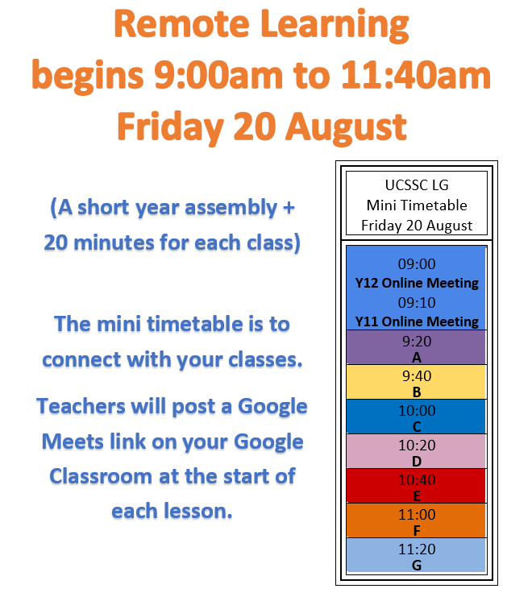
Remote Learning Mini-Timetable Day Friday 20 August
The mini timetable is to connect with students, explain expectations, check assessment due, and ensure students understand their timetable for the following week.

Students will attend their classes for this timetable via Google Classroom Meets. The timetable will also be distributed to students via Google Classroom.

Communication
Classroom teachers will be in regular contact via the Google Classroom platform as well as using whole class emails when important information regarding assessments arise. Parents will be included in important whole class emails that highlight any changes to the assessment schedule brought on by any lockdown issues.

Unit Outlines and Assessment
To meet BSSS requirements, teachers will notify their students about amended Unit Outlines, Assessment Tasks and Due dates on Monday of Week 7. Students will have time to provide feedback on amendments before all outlines are finalised by mid-next week.

If students have concerns or questions, please contact classroom teachers.

Remote Teaching and Learning at UCSSC Lake Ginninderra
Teachers at Lake Ginninderra will use a mix of asynchronous and synchronous learning during remote learning.

Synchronous Learning
Synchronous learning is teaching content directly with students live via an online platform. UC SSC Lake Ginninderra will do this during Connect Time, which will occur twice a week per subject.

Asynchronous Learning
Asynchronous learning is when students complete learning and class material at their own pace at a time of their choosing. Asynchronous learning materials will be posted by teachers on the Google Classroom at the start of each week and may include worksheets, readings, and work-related videos.
Connect Time – classes and learning
Students will meet with their classroom teacher twice a week for synchronous learning. This time will be used for students to connect with their teacher and peers. In these classes students can ask questions, seek feedback, work with their peers, and discuss class content and assessment.

It is important that students attend their Connect times for each of their five classes.

The Connect Time meets for each class will be organised on Friday 20 August during the mini-timetable day and communicated to students via Google classroom.

What will Connect time classes look like?
During Connect Time teachers will be using a range of teaching strategies to run class activities and provide opportunities for students to:
- discuss learning intentions/goals, relevant content, assessments, and the activities students are completing online during synchronous learning and their class time.
- check in and ask questions to make sure they understand the material being learnt
- seek feedback in relation to the concepts and ideas being studied or assessed
- receive feedback on work that was completed the previous week or since the previous Connect Time
- collaborate with others on class activities and forums
Connect time lessons will run up to one hour twice a week.
What platform will be used for Connect Time?
The preferred learning platform for classes will be Google Meets as it allows classes to meet in real time using audio / video and for classes to utilize chat room functions. Google Meets also allows screen-sharing so teachers can present documents, spreadsheets, and/or presentations.
Each Connect time, students should:
- Log on to the Google Meet ready to learn in an appropriate location, wearing appropriate attire. Google Meets are in the header of each Google Classroom page
- Have undertaken any asynchronous work set for completion prior to the lesson. This will be clearly communicated to students each Monday using the Google Suite.
- Come prepared to connect time with questions for their teacher
- Actively participate in learning activities set by the teacher.

How can students contact their teachers?
Students can contact teachers via email at <firstname.surname@ed.act.edu.au>, or they can use Google Classroom.
Is other support available?
Extra study help is also available through the library (11-1 each day) and through the Homework Program (Fridays after 1.30).

Registered units (R units)
Most R units are still running, including Academic Excellence, GiSTEM, Health, Medical and Applied Sciences, Production Ensemble and School Community Group (SCG), please check with your teachers.
Australian School Based Apprenticeship (ASbA) guidance during COVID lockdown
Students signed into an ASbA who unsure how current lock-down requirements are will affect their employment or training should access specific advice provided on the year 11 and year 12 classrooms for further information. Contact Fiona Chester in Student Services. Please let teachers know if you’re still doing them and when to assist you to complete your courses.

ACT Scaling Test (AST)
The AST has been cancelled for 31 August and 1 September.

Alternatives to be advised by the Board of Senior Secondary Studies (BSSS) in due course.

AST workshops continue for our students please check AST Google page.

Student Support Group (SG)
Support Group (SG) teachers will hold weekly Google Meet check-ins to check-in, update students on school news and offer opportunities for students to see and talk with others.

This routine is important; along with class check-ins, the SG group meeting will be held every Monday at the usual time of 11:40am.

All students should attend, and this session continues to contribute to an R unit point.

Wellbeing Check
A wellbeing check-in Google form will be utilised during Support Group. Students can submit the form at any time to request a check in. Students and parents may also request a check-in using lakegstudentservices@ed.act.edu.au

Both the forms and emails are checked daily.
Student Services
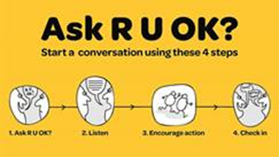
During lockdown our Student Services team are contactable and able to support students’ academic and well-being needs.

This may include referral advice, academic advice, access to internet, subject changes, university/CIT/work pathways advice, work experience and mental health support. LakeGStudentServices@ed.act.edu.au

Executive Teachers Graeme Budd and Gary Rolfe
Year 11 Coordinators Lane Moore and Ross McDonald and 12 Coordinators Graeme Budd and Kate Beattie
School Psychologist Suzanne Wright (Wednesday, Thursday, Friday)
Youth Worker Oliver Da Roza
Careers/Work Experience Officer Fiona Chester/Lisa Parker
Enrolments Officer Nicole McDonald
Study support
Academic support for students will be offered online by the library staff each day between 11:00am and 1:00pm.

To access support from the library, join via the library Google Classroom posted on Google Classrooms and Google Classroom Year pages.

Homework Program (Fridays after 1.30).
ICT Support
For students to be able to participate successfully during this period it is important they have access to appropriate IT hardware and internet access, they also need to be comfortable with the online software their teachers will be using.

All students should have access to a device; if this is not the case, please let us know via the survey below and devices can be provided. Students also need access to a good internet connection; if this is not the case let us know via the survey.

Please ensure students have completed the IT survey at https://forms.gle/BJp93fxAHrxrF69t6 if they have not already done so.

If a student is unsure about software or online applications their first contact for support should be their class teacher. If the issue cannot be resolved at this level please contact Roger Amey, Executive Teacher Science/IT roger.amey@ed.act.edu.au to help.

