NOTIFICATION of ABSENCE 2023

Student Surname: |  | Parent/Guardian:
Given Name: |  | Parent/Guardian number:
Mobile number: |  | Yr 11 - 12 | SG:
- Provide complete details for whole day absences in table below.
- Complete individual lesson absences in timetable - mark each box and include parent signature.
- Notification of Absence MUST occur within 7 days of a student’s return to college.
- The college policy requires students to explain all absences to fulfil assessment requirements.
- Submit Notification of Absence to Student Services. Advise class teachers of reasons for absence.
- Incomplete or unacceptable reasons for absence will be referred to students for further details from the Parent/Guardian

Note attachments: Medical certificate Letter Other (specify)
From: |  | To: |  | Signature: | Date:
Day | Date | Day | Date
Reason for absence:

TIMETABLE 2023
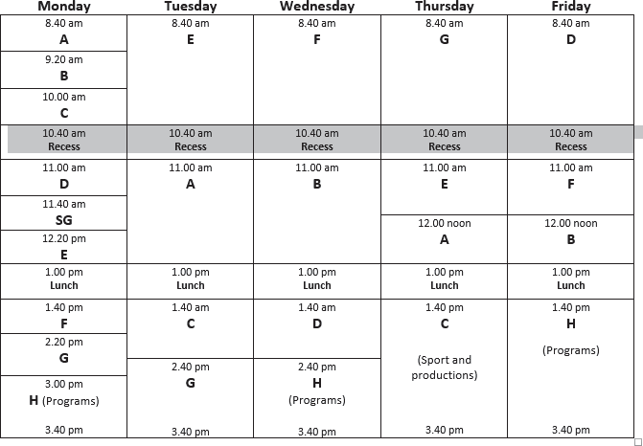
Parents please initial in the lesson spaces when absence is for part of a day.

Student Services Approval: | Yes No | Date received:
Notes: |  | Attend code:
 |  | Reviewed by:
 |  | Entered:

UC SSC Lake Ginninderra Attendance Policy - Explained

The Office of the Board of Senior Secondary Studies (BSSS) requires attendance at 90% of classes before a unit can be awarded. For our college, this means that a student cannot miss more than three lessons in a term unit or more than six in a semester unit. Students who total unexplained absences of 10% of lessons in a unit will be given a Void (V) Grade for that unit – no points, score, or grade for that unit towards a Senior Secondary Certificate. If a student misses a lesson or lessons the college requires an Absence Notification Form providing a satisfactory explanation. The college defines ‘satisfactory explanation’ as one that is supported by ‘appropriate documentation’.

Examples of appropriate documentation include:

• Medical Certificate or evidence of an appointment with a medical/dental practitioner
• Satisfactory written explanation of legitimate absence signed by parent/guardian for example:
        - Family Crisis or bereavement
        - Representative sport or equivalent
        - Religious or cultural observation
        - Carers leave
        - Attendance at court or other legal hearings

The college reserves the right to accept or reject an explanation (even if a signed note is provided).

Examples of unacceptable reasons for absence include:

• Missing class due to work commitments
• Missing class because you have a driving lesson
• Missing class because you missed the bus
• Illness without satisfactory documentation (see above)
• ‘Personal reasons’ where no detail is provided (or these reasons are repeatedly used)

The intention of this policy is to facilitate the early identification and reporting of poor attendance (including lateness). Teachers record student attendance at each lesson. To enable accurate and up to date recording and reporting of attendance the provision of adequate documentation (Notification of Absence Form and accompanying official documentation) to Student Services after an absence should not be delayed. In addition, we encourage families to contact the college by phone or email lakegstudentservices@ed.act.edu.au with information about planned or current absences prior to the provision of documentation.

If an Absence Form (see example following) is submitted but the explanation of absence is assessed as unsatisfactory, parents will be informed. Weekly attendance reports will be supplied through Support Groups. Support Group teachers and Student Services staff monitor student attendance. In the event of a prolonged or pattern of absence without notification the Support Group teacher will contact parents/carers.

In the event that school procedures encouraging attendance are unsuccessful the school is required to refer parents and young people to ACT Education.

If in doubt about the application of this policy, please see your Year Coordinator or contact the Deputy Principal on 6142 0222.

